THE DESIGN OF LBS SYSTEM
National Digital Switching System Engineering & Technological Research Center
Gao Bo, Wan Fangjie, Wu Zhiqiang
1001 Mailbox 860 branch Zhengzhou, Henan, China 450002
Tel: 0371-63530934
Fax: 0371-63530934
EMAIL:galber@vip.sina.com
Abstract:
Along with the opening of new generation network for the company of telecommunication and mobile communication, data business become more and more important. Cell phone is not only the implement for communication, but also for getting information. So, it will be the chief business for telecommunication administration to supply the wireless incremental service. In all kinds of service, because of the mobile characteristic of cell phone, incremental service related to location will become the greatest growth point. In order to win the service competition of wireless internet, the guarantee of critical contents supplying is especially important, and among these contents, LBS which is a information service that could tell the location of mobile users is becoming one of the most important portion.
Firstly, the paper discussed the technology which is demanded by the Location Based Service, the technology included: 1st, the kind of location service. 2nd, the precision of location that different applications needed. 3rd is the location finding strategy. One of the kernel technologies in LBS service is location information, and the other is geographic information. They’re complement and indispensable each other. As a result, we not only get location of the terminal by platform of location operation, but also converse the value of latitude and longitude to the geographic information which is cared by user, such as, map, consequence of path search and so on. In LBS system, those service should be supplied by GIS: Mapping，Directory, Route, Geo-code, Reverse Geo-code, Cogo and Navigation.
Secondly, the paper introduced the construct of LBS system, which includes: the construct of hardware, the construct of software, and the characteristic of LBS platform
Finally, the paper introduced the function which can be accomplished by LBS. Basing on the location service system, consummate wireless network, geography information data and information searching engine, the LBS can supply rich location information service for users, as follows, personal security and succor, machine’s anti-robbing, group vehicles’ management, dispatch and management of people and rental equipment, information services that related to location, flow of material’s management, advertisement, friendship and entertainment service, etc.
There’re broad prospect for LBS business, at present, the applications of LBS become more and more popular. The mobile communication and GIS should be combined to accomplish the LBS business. We believe that LBS business will be applied broader and broader along with the constant growing demand and development of GIS in our country.
Key Words:
LBS GIS Oracle Spatial

Introduction
Along with the opening of new generation network for the company of telecommunication and mobile communication, data business becomes more and more important. Cell phone is not only the implement for communication, but also for getting information. So, it will be the chief business for telecommunication administration to supply the wireless incremental service. In all kinds of service, because of the mobile characteristic of cell phone, incremental service related to location will become the greatest growth point.
All of the international mobile communication company’s earning in data business almost exceed than in voice business. In the United States and Europe, the wireless incremental service that related to location is an important part of data business. Through the mobile phone users in china are very huge, and the mobile communication network is maturity, but the location service is inchoate, so there has a large business chance.
In order to win the service competition of wireless internet, the guarantee of pivotal contents supplying is especially important, and among these contents, LBS（Location Based Service）which is a information service that could tell the location of mobile users is becoming one of the most important portion.
According to a statistic, there has 80% information is related to location in the people’s life. People waste a lot of energy to find a person or a place. In modern society, the real time position information is one of the most desired one. The LBS just fit this demand. At the United States, this service is called WLS, named Wireless Location Service, and have already became a big size profession organization. The capital field also has tremendous enthusiasm in this service, after fled from the .COM, the capitalist of Wall Street infuse the funds into this newly arisen industry. A company which is called OnStar becomes the biggest wireless position service company in North America; its parent company is being see to symbol of as the American traditional industry, G.M. company.
Along with the using of CDMA 2000 1X, the foundation that LBS depended on already is provided, as a result this market already grows up. The customer can find the destination according his position just need to pay a little; can find out the destination that one need on the color-screen cell phone according to the position.
- What is LBS?
LBS is a wireless incremental service that related with position. It is an information service that based on network positioning, database, GIS (Geographic Information System) and dynamic web page.

2.1 The category of LBS
The LBS has four types, like in the figure 1.
Security  Emergency service  Roadside help | Pay  Pay based on position  Wireless office  Pay based on affair
Information  living information  accident information  traffic information | Tracing  Marine tracing  Possession tracing  Person tracing
Figure 1: The Category of LBS

2.2 Positing precision that different applications needed
The precision that different applications need is also different, obviously, for the ship, the distance between the ship and coast and the depth of the water need the high position accuracy, but 100 meters precision can accepted for the crowd.
Some applications that based on position are enumerated in figure 2, and provided these applications’ the bottom limit precision and the precision that can be accepted by the market.
Along with the improvement of positioning accuracy, the drive piloting, roadside helping, the crowd tracing etc., the service will become more and more widespread. For some users in early days, if they knew that their trucks or package are in which part of the city, they will feel satisfied. But for most commercial customers, they hope to know their properties or the kid's accurate position. And the most complicated position service, drive piloting, need higher positioning accuracy and frequency.

Application | the bottom limit precision | Accepted precision | Equipment customize | Purpose
Pay based on position | Cell area | 250m | Don't need | Low price
Roadside help | 500m | 125m | Don't need | Send help
Mobile yellow page | Cell area | 250m | Don't need | What in my neighborhood?
Traffic information | Cell area | Cell area | Don't need | What about the traffic?
Message based on position | Cell area | 125m | Short message or data | Advertisement, Alarm, message
Marine tracing | Cell area | 30-125m | Don't need | Resource manage
Package tracing | Cell area | Cell area | Need | Positioning and directing
Drive piloting | 125m | 30m | Need | guidance
Figure 2: Some applications’ the bottom limit precision and the precision that can be accepted by the market

2.3 The Strategy of Position Finding
For the mobile positioning service has a wide choice techniques, the solution include network based and cell phone based. The technique that based on cell phone includes GPS (Global Positioning System), E-OTD (Enhanced Observed Time Difference), TOA (Time of Arrived), and COO (Cell of Origin).
The technique that be used widely in the wireless network is COO. This project has already been used in the first stage of "911" emergency service in the United States, wireless office and some services that need positioning information.
The T1P1, a branch of ANSI (American National Standards Institute), and ETSI (European Telecommunications Standards Institute) Handed over a standard of position finding system in 2003, they decided to adopt E-OTD, TOA and assisted GPS (A-GPS) to supplement COO. Following is a simple introduce of those technique.
2.3.1 Cell of Origin (COO)
The COO technique has never needed to modify the cell phone and network, so it can be use to provide position to the current mobile users. But, comparing with other techniques, the accuracy of COO is the lowest. Some people say that the precision of COO is enough in the city, because the area is very small. However when we need PFS (Position Finding System) to provide an emergency service, the COO’s accuracy is a problem that can't be neglected.
In this system, the cellular field which mobile communication base located is the positioning unit of user. So, the positioning accuracy is decided by the density of cellular. Perhaps the cellular’s field in the center of city just is 150m. Although other technique projects can provide higher accuracy than the COO, however the biggest advantage of COO is very quick to respond the position information (round about 3s), and doing without update cell phone and network, it can directly provide the position service to the existing customer.
2.3.2 Enhanced Observed Time Difference (E-OTD)
The realization of E-OTD is based on placing position receiver or reference, and these references distribute in many stations in wide area. Those references cover the wireless network as a LMU (Location Measurement Unit). Each reference has an accurate time source. When the cell phone that has the function of E-OTD receives the signal that come from at least 3 mobile communication base, the time difference from station to terminal will be calculated, these difference can be use to produce several cross hyperbola, and use this to estimate position.
Similar as the Arrived of Angle (AOA), the E-OTD will be influenced by the multi-path effects in the downtown. At this time, the multi-path will distort signal wave form and add delay, so it will be difficult in deciding the signal observing point.
E-OTD project can provide much higher than the COO positioning accuracy, between 50-125 meters. But the speed of response is slower, usually about 5 second. Moreover, it needs to modify the mobile phone; it means that the existing customer can't use this technique to acquire position.
2.3.3 Time of Arrived (TOA)
Like E-OTD, the TOA also acquires the position information by calculating the time difference of signal from station to terminal. But the difference is, the TOA system is not using position measuring unit, but carrying out by the synchronization between the terminal and the wireless network which installs GPS or atom clock. The American cdmaOne network used this function. The positioning accuracy that the TOA provides in the downtown is better than COO, but it needs longer response time than the COO or E-OTD, about 10 minutes.
The price that GSM network synchronization is higher than improving the network functions in COO. Carriers probably will not investing in the way. But the TOA have never needed modify the mobile phone, so it can directly provide the service to the existing customers.
2.3.4 Angle of Arrived (AOA)
The technique of AOA is developed by the military and the government at the beginning, and it doesn't need to modify the mobile equipments. Afterward, this technique is used in simulative wireless communication. Because the digital mobile communication’s signal is very short, and the channel is sharing, so the AOA technique is very difficult to apply in digital system.
The most common edition of this technically is called "gap direction finding", it needs to place 4~12 antenna arrays in each mobile communication base, these antenna arrays work together, so it can determine the angle of the mobile equipment relative to station consequently. When multi-station discovered the angle of the signal's source, so it can draw radial from the base along the angle separately, point of intersection of these lines is the position of mobile phone.
Along with communication laws of continuously strict, the biggest disadvantage of AOA system is that it will be very trouble to add antenna array in cellular base, and the existing antenna is also unsuitable for an AOA technique. Another disadvantage of AOA system is if the angle of base has a little error, it will cause bigger error when the mobile phone is far from the station.
2.3.5 Signal Attenuation
When the mobile phone closes up or apart from the base, the signal's attenuation will change. The terminal's position will be estimated using this technique. If the signal power of telephone has been know, if the signal power be surveyed at another place, the distance between the phone and this place will be estimated using a transmitting model.
However, because of various reasons, this technique is thought to be the most fallibility in all the positioning technique.
It is very complicated to find the transmitting power, and the signal's attenuation is not only related to the distance, but also another elements, such as wall, plant, metal, glass, vehicle and so on. All these elements affect the signal's power. The circuit of power measurement can not distinguish those powers from multi-direction, such as directly and reflected.
The characteristic of different type of technique shows in Figure 3.
The technique | Based on | Advantage | Disadvantage
COO | Network | Do not need to modify network and mobile phone | The precision is low
E-OTD | Network |  | Need modify the software of mobile phone
TOA | Network | Using the exist CDMA network | The precision is low
GPS | Mobile phone | Free high precision | Need new type mobile phone
AOA | Network |  | Need complex antenna
Figure 3: The characteristic of different type of technique

The structure of LBS system

The structure of LBS system hardware
The structure of LBS system hardware shows in figure 4. The customer puts forward a positioning request through various terminals; the LBS system get the position information according to the customer's related information after receives the customer's request, then send out the location and related information to the customer.
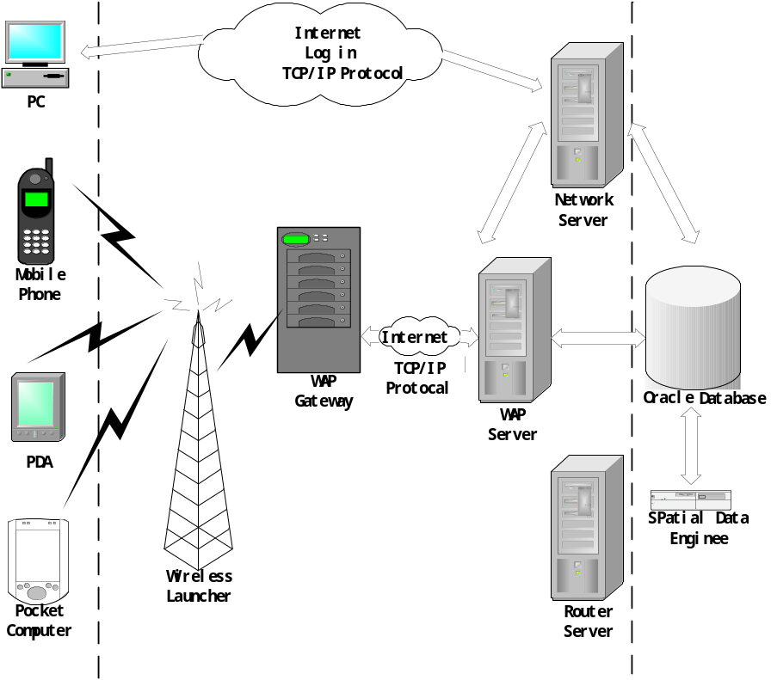
Figure 4: The structure of LBS system hardware

The structure of LBS system software
3.2.1 The composing of LBS platform
The structure of LBS includes four parts: The B/S structure, C/S structure part, database part, maintenance system part. The underneath is a simple description.
3.2.1.1 B/S structure
The B/S project completes the mobile target’s real time watching, navigating and emergency processing business through WWW. This project can nicely satisfy the customer's requirements, and easy to enlargement. The program is centralized in the server, and customer just needs a browser and then can browse, search various businesses information. Because of using B/S structure, not only can satisfy at all requirements now, the number of customer can increase hereafter at will, and fits the tide of development. The modification and renewal of data can be carried concentration (using maintenance system) by the server, and can also be modified from each part of the center and then delivered by the C/S structure.
- Web Server
The Web Server accepts the clients (PC browser, PDA, wireless cellular phone) the request of graphic data and business sheet data which sends out by HTTP protocol, the TCP/IP protocol or WAP protocol, and transmits these request to application server, the application server processes those business logic, then send the result (graphic data and business sheet data) that the application server return to the client.
- Application Server
The application server accepts the customer’s request by providing WEB service on Internet/Intranet, and executes corresponding operation, then return the information to customer.
By the spatial database middle ware, the system acquires various graphic data and the grid space image data from the data platform center. The substrate interface can use standard SQL language obtains the data from the center database, and it can also read files to obtain the data.
The system provides a respond to the best path requesting. According to the topology and traffic information of road, system returns the best path information, and shows it in the symbolization way.
- Client（The browser in PC, PDA, mobile phone）
Using the HTTP protocol, TCP/IP protocol, WAP protocol or Short Message Service (SMS), the client can request map or data to the WEB server. According to the corresponding protocol, the client explains the data (including vector data, grid data and text data) that sending from the WEB server. The client language, such as VB Script or JAVA Script, can provide well visual interface. So the client can show map or manage business dynamically.
3.2.1.2 C/S structure
The C/S structure of the system is mainly used for watching business management in the center local area network, and fulfills the watching business that undertaken by the sub-center. Especially when the graphic data is huge, and needs high precision print, the C/S structure is better than B/S structure.
Using universal developing tools just like VB, VC, Delphi, Power Builder etc, and the MapX is embedded to the client of the system C/S structure to customize application program, and make use of a SQL sentence to connect with center database to obtain various data. The purpose is business management and graphic maintenance.
3.2.1.3 Database
Oracle is selected as the database tool. The Oracle database has two data engine, one is Oracle Spatial, the engine of managing spatial data, and the other is Image Cartridge, the engine of managing image data. Map data file and grid image file are uploaded to the database by the uploading tools. The map data, attribute data and the profession data are saved in the Oracle. The Oracle Spatial can save the complicated map objects into the large database, and establishes the spatial data index, consequently realizes a uniform management to the attribute data and the spatial graphic object data on the database server. The Image Cartridge can effectively manage the various image data, and establishes image index.
3.2.1.4 System maintenance
The system maintenance uses MapInfo Professional to update the fundamental data. While needing to update the data, MapInfo Professional can used directly to update the graphic data and attribute data, and uploads those data to data servers in order to release data.

GIS in LBS
The core technique of LBS service one is positioning information, another is geographic information, both are complement each other. A longitude and latitude is mean nothing for the normal user. It must be placed in geography information, and then it can represent a certain location, marking, directions, etc., afterwards, it can be comprehended by people. Therefore, in addition to the position that obtained by the position operating platform, it must be converted by the GIS system to the geography information which is cared by user, such as the map, path searching result etc. In the LBS system, the GIS must be able to provide the following service:
(1) Mapping
According to the LBS terminal request (such as map field, map layer, drawing style etc.), the GIS returns map data. The map data can be raster map, or specifically vector data.
(2) Directory
Mainly function is the finding of point of interest POI (Point of Interest), such as hotel, restaurant and entertainment.
(3) Route programming
It can provide how to go to another point from a place; it is useful to driving, walking etc. It has multi-type methods, such as time preferential, distance preferential, expense preferential. The route programming is an important service in the LBS business, and it is service that incarnating the mobile network’s advantage and characteristic.
(4) Geo-Code
Changing an address or post code to a geography position.
(5) Reverse Geo-code
Reverse a geography position to an address or post code. So the customer can get an visual position information.
(6) Cogo
This function is surveying geometry element. Such as the distance of two places, the length of a road, etc.
(7) Navigation
Navigation is the process that directs the driver running along the path that calculated by the route programming. This process can be carried out in the trip or before the trip.

The function of LBS
Along with the developing of society, and the emergence of super big city, the geographic information and position information are more and more recognition by people, and even change and influence imperceptibly the life of people in the daily life. For example: finding restaurant, hotel, entertainment center, shopping center, bank, tour spot, etc. Along with the development of the technique and the network environment, the position information service will become our best guides.
Mentioned above, according to a statistic, approximately 80% of people's activity is all relates to position, so the position service is more and more important. The position service system combines self-contained wireless network and geographic information data and information search engine; it can provide abundant position information service to the customer.

Person security and emergency help
Currently, our country’s person security and emergency help system just only depend on settled telephone, it is very inconvenient to the person that want to call the police but do not has mobile phone, and even make it impossible if there has an unexpected patient or attack. But if the person has a mobile phone that supports the LBS, it becomes very easy. The United States has already ordained that all cellular phones have to have a position reporting function from October, 2001. Some nations in Europe also started the application in this aspect.

Vehicle anti-robbing and guard against theft
Comparing with the currently guard against theft system, the LBS system has following characteristics:
- Very small and light, so it can be fixed in any position, and it is difficult to be found by the thief.
- Do not be affected by the shelter, so it can position inside or outside.
- Comparing with GPS, it is very cheap. If using mobile phone as positioning terminal, the price is under 1000 Yuan.
- The security of system is all in our country’s control, and need not depend on the fremdness.

The managing of motorcade, personnel and rented equipment
In many conditions, the manager needs to dispatch the motorcade and personnel to improve efficiency and promote service quality, like postal service express delivery, emergency maintenance service etc. The manager hopes the motorcade and personnel that near the customer can arrives the appointed position as fast as quickly. Compared with the GPS, the characteristic of LBS is very evident. Manager can know the motorcade and personnel’s position even they are in building or shelter.

The info service that related to position
LBS can provide various information services that related with position. When the customer in a strange region and wants to know the nearest store, bank, bookstore, hospital etc., he just uses LBS, then the information that wanted will be displayed on the screen of mobile phone. When a person wants to buy something, the positioning system and information database can guide him. The LBS can even cooperate with websites and provide abundant information service.

Advertisement
Along with the development that mentioned above, it must attract numerous advertisers to insert ad in this business. The method is adding 1 to 2 seconds advertisement before the position information that users received. This effect will better than paper even than TV advertisement.

Good-fellowship and entertainment service
Using LBS, The users can know friends position, send greeting, and even play games that based on position.

Conclusion
Lots of people agree that the LBS is an important increment business in 21 century. To mobile user, position not only is a characteristic service that know oneself or others position, more important relate to oneself and property safety of each mobile user. Along with the technical development, the position service will provide higher positioning accuracy to the customer, more convenient operation method, and more comprehensive position information. So there will be broad prospect for LBS business, at present, the applications of LBS become more and more popular. The mobile communication and GIS should be combined to accomplish the LBS business. We believe that LBS business will be applied broader and broader along with the constant growing demand and development of GIS in our country.

